**Agriculture Website**

1. **Product-based**
2. **Requirement Analysis:**  
   **-** Understanding the needs and preferences of the farmers, agricultural professionals, agribusinesses, researchers, policymakers, and agricultural enthusiasts.  
   - Market prices and agricultural commodities trading  
   - Agricultural education and training materials
3. **Target Audience:**  
   - Small-scale and large-scale farmers are a primary target audience for agriculture apps.  
   - Wholesale business vendors  
   - Government Agencies and NGO
4. **Project Timeline**
5. **Color Palette:**  
     
   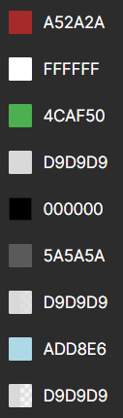
6. **Fonts:**  
     
   - Headings/Events Names: ANTIQUA  
   - Navigation menu: Georgia Pro  
   - Events Description: CALIBRI/INTER  
     
   reference: fonts.google.com
7. **Images:**  
     
   - Vectors: Logo, Navigation icon, Hamburger menu, Contact details icons  
   - Rasters: All Comodities pictures
8. **Screen Size:**  
     
   - 1920 x 1080px
9. **Primary Device & Browser:**  
     
   -Desktops/Laptops  
   -Google Chrome/Firefox
10. **Frameworks:**
11. **Mockup:**  
      
    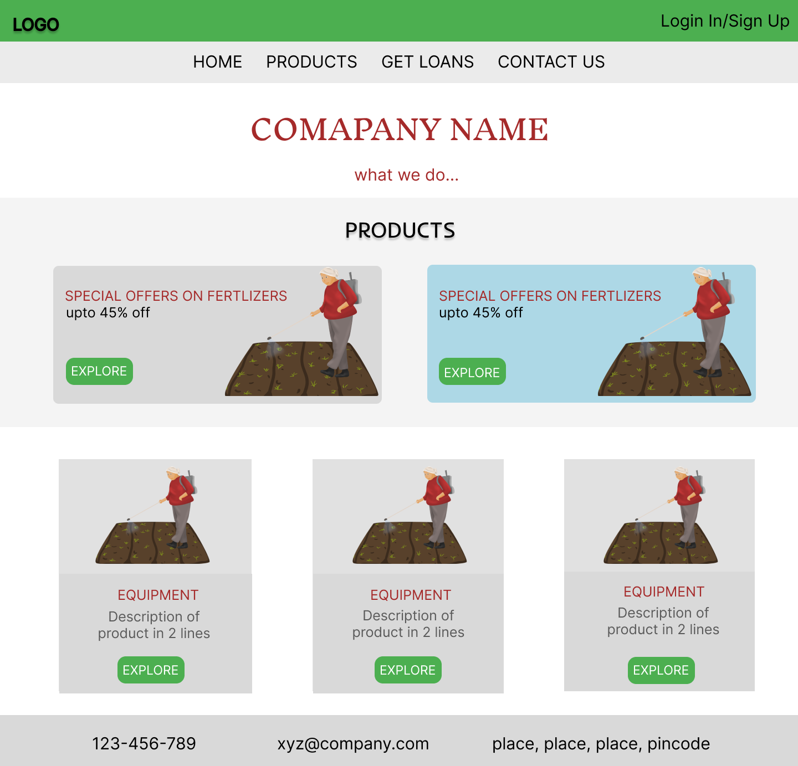
12. References:  
      
    - https://muffingroup.com/blog/agriculture-websites/